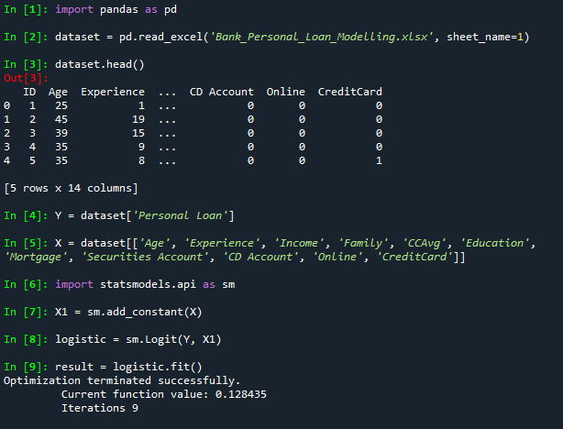

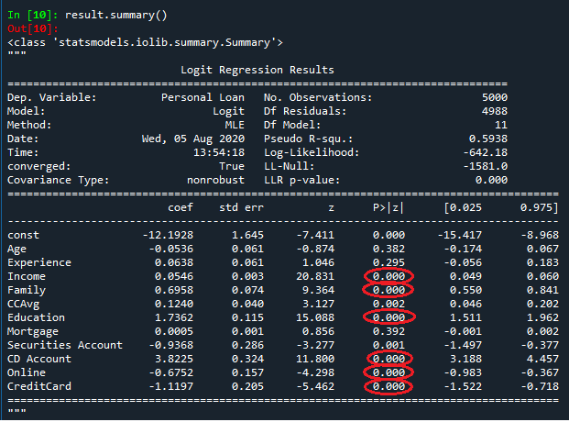

1. As Income, Family, Education, CD Account, Online and CreditCard have p-value 0, they have a high cause-effect relationship with loan Acception.
2. P-values of CCAvg and Securities Account are also extremely close 0.
3. While p-value of Mortage and experience is high, so they do not have a high cause-effect relationship